M5.2 Assignment
Course: CSD310 – 340A
Prepared By: Mirach Erkol
Date of Report: 11/16/2025

https://github.com/Mikey5007/csd-310.git

M5.2 Assignment:

LOCATE()
The LOCATE() function searches for a smaller piece of text inside a larger string. It returns the position number where the substring first appears. If MySQL cannot find the substring, the function returns 0.
This function is helpful whenever you need to determine whether a specific word, letter, or symbol exists within a piece of text. For example, you can use it to check if an email address contains an “@” symbol, or to find where a word appears inside a sentence.
Alias – ‘Position Found’

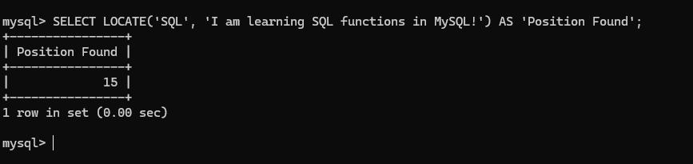

REPLACE()
The REPLACE() function lets you swap out part of a string with something else. It searches for a specific word or set of characters within a piece of text and replaces it with whatever you specify. If the text you’re replacing doesn’t exist, nothing changes.
This function is helpful when you need to clean up data or fix mistakes. For example, if a list of movie titles used “&” instead of “and”, you could use REPLACE() to automatically correct them.
Alias – ‘Updated Text’
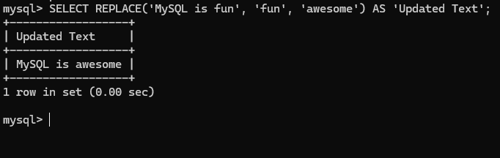

TIME_FORMAT()
The TIME_FORMAT() function allows you to change the display format of a time value. It takes a time (like 14:30:00) and formats it using a pattern you choose. This makes it easier to present time in a way that’s more readable to people, such as converting 24-hour time into 12-hour time with AM or PM.
This function is helpful when you want to show time in a clearer format on reports, schedules, or user interfaces. For example, a movie theater app might want to show “02:30 PM” instead of “14:30:00”.
Alias – ‘Formatted Time’
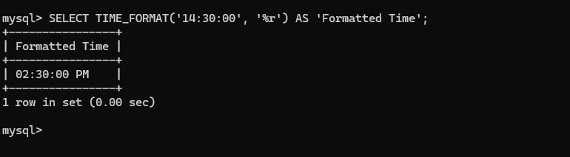

Mikey5007/csd-310: CSD

